4. Methodology
4.1 Methodology introduction
This study focuses on the use of a suitable reinforcement learning algorithm for the creation of intelligent agents which can adapt to different scenarios in an RTS-like environment.
Generally, RTS games make use of grids and deterministic algorithms for pathfinding. In Metal Warfare, for example, Thien (2018) explored the use of ML-Agents to create intelligent agents within an RTS game but despite this, pathfinding was not addressed due to the game’s design nature. Other notable examples are the study by Vadim, Tatyana and Oksana (2018) and the one by Lai, Chen and Zhang (2019), which employed ML-Agents in their methodologies but did not focus on RTS games.
This study addressed pathfinding in an RTS-like environment by implementing two of the training methods offered by the ML-Agents toolkit, Generalized Learning and Curriculum Learning. Two separate prototypes which incorporate these methods were developed with the aim of exploring on the subject and providing satisfactory results.
Generalized Learning allowed for the agents to be trained in environments that change periodically during training; Curriculum Learning was used to slowly increase the difficulty of the agent’s task while it trained. After training, the agents were expected to be able to go to any navigable part on the map in reasonable time while avoiding any obstacles in their way. They were also expected to perform well when new obstacles are introduced to the environment.
This section will outline the approaches and technologies that were essential to conduct the study along with the justifications for using them. In addition, it will highlight the prototype’s capabilities and limitations.

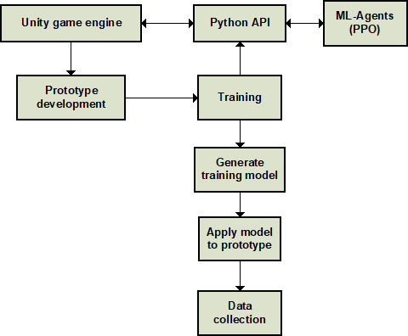
Figure 1: Research methodology process

4.2 Technologies used
As shown in Fig. 1, the Unity engine was used to develop the prototype and train the agents via ML-Agents, which communicates with the engine via the Python API. After each training run, a model was generated and applied to the prototype so that the agents could perform inference and have their performance analysed.
4.2.1 Unity & C#:
Unity was used to build the environment for the agents. Originally released in 2005, Unity is a game engine which allows for the creation of 2D and 3D interactive media. It was chosen because as Juliani et al. (2020) state in their paper, Unity and ML-Agents are an instance of a general platform, meaning that “the underlying engine is not restricted to any specific genre of gameplay or simulation (Juliani et al., 2020). In Unity, GameObjects can be accessed and manipulated via C# scripts.

4.2.2 Visual Studio:
Visual Studio was used to write the scripts for the prototype. It was chosen due to the Visual Studio Tools for Unity extension, which was developed to add Unity-specific functionality to the IDE. The extension introduces better IntelliSense, a scripting wizard that allows for the viewing and implementation of all the Unity API methods, a Unity project explorer, and the ability to debug editor and game scripts.

4.2.3 ML-Agents (v0.15.1):
As stated in its documentation, ML-Agents is an open-source plugin for Unity. It enables developers to train intelligent agents within Unity itself. Imitation learning and curriculum learning are amongst the implemented training methods. ML-Agents provides a Python API which is used by the training algorithms. The training process is started from Anaconda Prompt through a command that can accept a multitude of parameters for specific functionality. ML-Agents was used to train the agents and generate a model for inference.

4.2.4 PPO:
The ML-Agents toolkit comes with an implementation of the PPO and Soft Actor-Critic (SAC) reinforcement learning algorithms. As the toolkit’s documentation states, “PPO has shown to be more general purpose and stable than many other RL algorithms”, making it the ideal choice for this study (Unity-Technologies/ml-agents, 2020).

4.2.5 TensorFlow:
Statistics from learning sessions are saved by the ML-Agents toolkit and can be viewed with a TensorFlow utility called TensorBoard. It provides the measurements and visualisations, such as the learning rate, for example, in the form of graphs. Since these statistics are saved, they can be viewed at a later stage, which in turn makes it easy to analyse and compare data between different training runs.

4.2.6 Anaconda:
Anaconda is a free, open-source distribution of the Python and R programming languages aimed towards data science, including a plethora of packages related to the field. Moreover, it also includes Conda, which is an open-source management system for packages and environments. During the development process, ML-Agents was updated several times. As such, environments were used to isolate each version along with its dependencies and any required packages.

4.2.7 Python:
Python was used because it is required for the API provided by ML-Agents to train the agents and communicate with the Unity editor.

4.3 Study overview

Since this study focuses on the implementation of reinforcement learning in RTS games, an environment had to be built which comprises RTS-like properties. Several factors had to be taken into consideration, such as the fact that in an RTS game, the environment changes frequently due to player actions.

To accelerate training in ML-Agents, agents can make observations of the environment’s state for them to be able to make informed decisions. As stated in the ML-Agents documentation, agents come with a VectorSensor by default, which allows them to collect floating-point observations into a single array. Observations are categorised into three; visual, vector and raycast observations. Vector observations are ideal for numerical environment aspects, which include, for example, the position of an obstacle. Visual observations, on the other hand, are ideal in situations where something of arbitrary complexity which is difficult to describe numerically needs to be observed. These are typically slower and less efficient than vector observations to train. Raycast observations work by having several rays cast into the physics world. The observation vector that is produced is determined by the objects that are hit by the rays.
For the prototypes, a combination of vector and raycast observations were used.
The vector observation size cannot be changed during training, which is a limitation. In cases where an ever-changing environment must be observed, there is no way to observe, for example, obstacles which are not there yet, otherwise, the agent could be given the positions and size of the obstacles to help it avoid them. Moreover, as stated in the ML-Agents documentation, agents tend to overfit when trained an environment that does not vary; they are unable to handle slight tweaks or variations in the environment after being trained. This applies to RTS games, in which the level usually changes as players expand their base and build more units, resulting in different objects and properties. To tackle this, the agents were trained in multiple variants of the environment. As a result, they were able to adapt to environments with objects or properties that were not originally present during training. The environment varies periodically during training; the frequency with which it varies is defined by the user. For this study, the environment’s floor size was set to change to a random number throughout the entirety of the training process. In addition, several obstacles of varying sizes were set to spawn spawned to train the agents to avoid them (Fig. 2). The number of obstacles that spawn is dependent on the floor size – i.e., the larger the floor, the more obstacles that will spawn and vice versa.
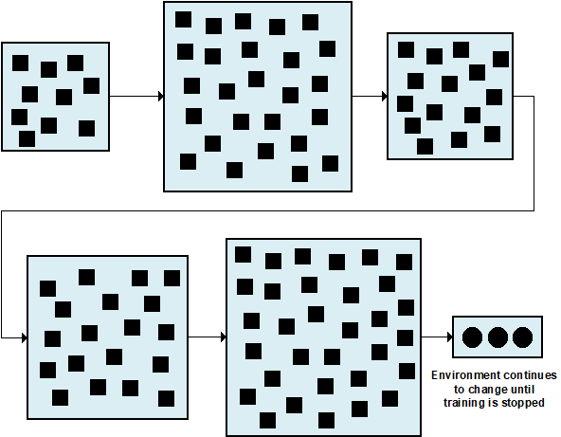
Figure 2: Generalized agents training; the environment complexity is changed every few steps.

In addition to the above approach, an attempt was made to train the agents via curriculum learning but once the agent progresses to the last lesson, a timer resets the obstacles in the level every few minutes like what is done in generalised learning. The difference is, though, that in this case the obstacles were reset manually through code rather than automatically by the Python API. This involves having the agent start with simple tasks and then increasing the difficulty as it accomplishes them (Fig. 3). As opposed to having the agent immediately start training in a large map, the floor size was set to increase as the agent accomplishes its tasks.

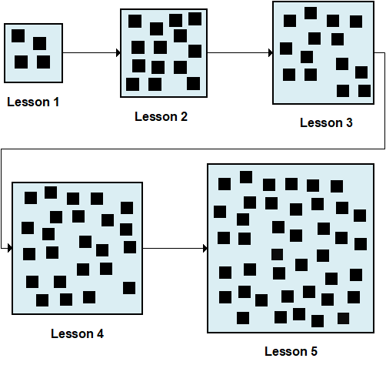
Figure 3: Curriculum learning training; the environment complexity is increased each lesson.

Experimentations were done with rewards until an optimum combination that leads to good results was found. The agent was given a reward when it reached the target and penalised whenever it collided with obstacles and other agents, for example. Although it is generally recommended to reward results rather than the actions that lead to them, the study by Vadim, Tatyana and Oksana (2018) has shown that giving rewards based on actions can help during training.

4.4 Developing the prototype:

4.4.1 Setting up the projects in Unity:
For the study, two separate Unity projects were created; one for each approach. This had no effect on the collection of results, but having separate projects was preferred over the use of a single project for both approaches for two reasons:
- Each project’s assets are kept in isolation from one another, reducing the possibility of editing the wrong asset, consequently causing problems which might go unnoticed for a while.

- Better control over both projects, which in turn reduces complications in case of problems.

4.4.2 General project setup:
The project learning environments for both approaches comprised of the following GameObjects (Fig. 3):

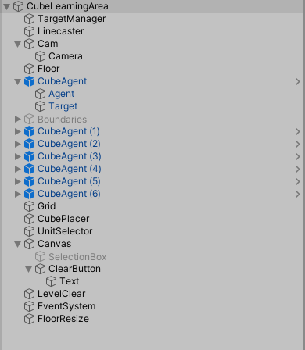
Figure 3: The Unity project’s contents.

- CubeLearningArea (empty GameObject): This is the learning environment itself. It acts as the parent for all the other GameObjects by encapsulating them, providing the ability to make it a prefab and create duplicates of it to accelerate the training process. A script was created and attached to it which handles any modifications which must be done to the environment during training, such as resizing the level and instantiating cubes.

- Floor (3D plane): Acts as the floor for all the other GameObjects.

- CubeAgent (empty GameObject): This acts as the parent for the agent and its target.

- Agent (cube): The agent itself. Several components were added to it:

  - Rigidbody (Fig. 5): Enables the agent to act under the control of physics, such as move around and interact with other objects.

  - CubeAgent script (Fig. 4): This script contains all the necessary logic for the agent. The agent was set to respawn if it falls off the level or reaches its target.

  - Behaviour Parameters script (Fig. 4): Used to set training-related parameters such as the behaviour name, vector observation size, vector action size and model.

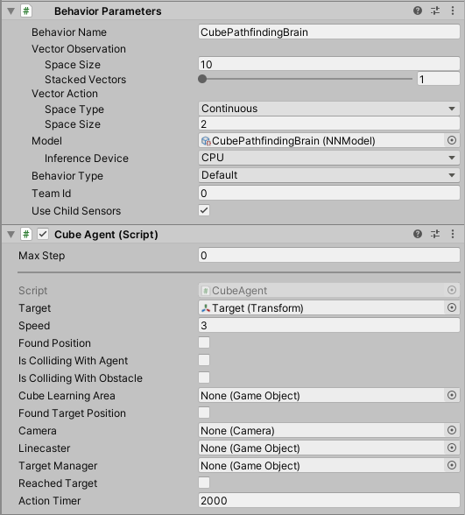
Figure 4: Agent scripts (Cube Agent and Behaviour Parameters).

  - Decision requester (Fig. 5): Enables the agent to request decisions on its own at regular intervals rather than manually.

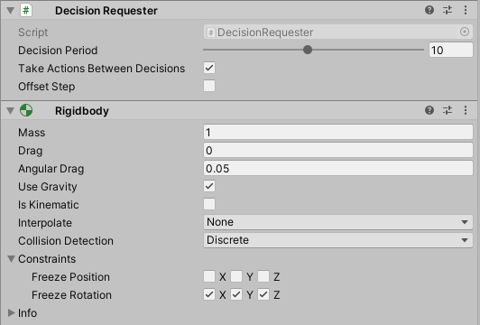
Figure 5: Decision Requester script and Rigidbody component.

  - Ray Perception Sensor 3D (Fig. 6): This component was added to provide observations to the agent by casting several rays into the physics world. This essentially helps the agent perceive obstacles, agents and its target. The observation vector that is produced is determined by the objects that are hit by the rays.

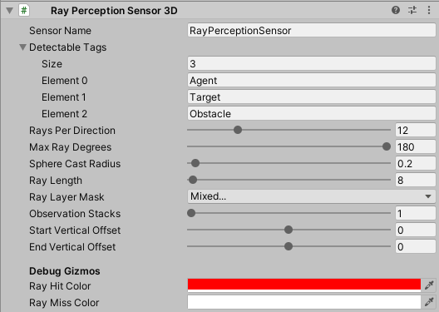
Figure 6: Ray Perception Sensor 3D component.
- Cube (target): Every agent has this object as its child, which is a small cube that acts as its target.

- Obstacle (cube): This was added to act as an obstacle for the agents for them to be able to avoid it.

Following the creation of the learning environment, several additions were made to the Unity project in order to make the prototypes playable. The following were added:
- Camera movement and zoom;
- A button that clears the level when clicked;
- The ability to select multiple units;
- The ability to move selected units by right-clicking anywhere on the 3D plane;
- When multiple units are selected and sent to a location, the targets are scattered evenly in the form of a circle around that location.

Other minor modifications were done to the code:
- The distance from the target at which an agent must stop was set to 2.5 from 1. This was done to create more room for when the agents are sent to a location as a group.
- The ML-Agents environment reset function was commented out.
- The end episode function call was commented out.
- The agent’s speed was set to become 0 whenever it reaches its target.
- The agent’s speed was set to become 4 whenever its target is moved to a new location by the player.

The above additions and modifications were made with modularity in mind, meaning that they can be easily enabled or disabled as needed without requiring major changes to the project.

4.4.3 Vector actions:

The agent was given the ability to move in three dimensions.

4.4.4 Vector observations:

- The agent’s own local position;
- The target’s local position;
- The agent’s X velocity;
- The agent’s Y velocity;
- A Boolean which indicates whether the agent is colliding with another agent;
- A Boolean which indicates whether the agent is colliding with a wall.

4.4.5 Rewards:

The agent was given a small penalty of -0.00016 for every action it performs to encourage it to take the shortest path to a target. It is worth noting that for both approaches, a timer was added to trigger this penalty after the agents had spent some time training. For curriculum learning, this penalty was triggered when the agent progresses to the final lesson. Having it active from the start has shown to impede training.

A penalty of -0.00025 throughout the time it spends colliding with another agent.

A penalty of -0.0005 throughout the time it spends colliding with a wall.

The agent’s reward was set to 1.0 whenever it reached its target.

4.4.6 Training:

The training hyperparameters were set as shown in Fig. 7. Several other parameters exist, but if they are not set, ML-Agents gives them a default value. Several different configurations were tried but overall, these hyperparameters have shown to yield good results.

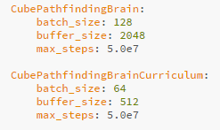
Figure 7: Hyperparameters for generalised learning (top) and curriculum learning (bottom).

The sampler (applies to generalised learning) was set to change the floor size to a random float number between 3 and 20 every 3000 steps (Fig. 8). Experience has shown that a low minimum allows the agent to better familiarise itself with the environment. Moreover, very high numbers have made training the agents impossible due to the extreme size of the floor.

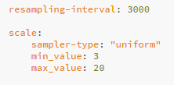
Figure 8: Sampler configuration.

The curricula (applies to curriculum learning) was set as shown in Fig. 13 so that the floor progressively grows to 20 as the agent performs better. The lesson advances based on the agent’s cumulative reward.

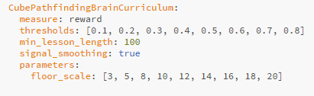
Figure 9: Curricula configuration.
Training was performed with 25 learning areas each containing 7 agents. This was done to accelerate training. After training, the generated model was assigned to the agents for inference (Fig. 10). For curriculum learning, a timer was set to reset the obstacles every 300 seconds when the agent progresses to the last lesson.

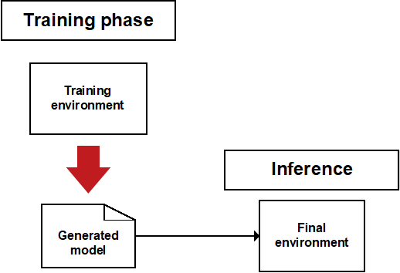
Figure 10: Training process.

4.5 Prototype limitations
For the study, the map size was limited to 20 by 20 because bigger maps have shown to hinder training severely.
During the development stage, it was observed that the agents would react poorly to obstacles that are too close to each other. This was mitigated by implementing snap-to-grid building placement.
This study excludes terrains because they would have added too much complexity to the study and prototype due to the increase in factors that would have had to be taken in consideration.

4.6 Research methods

For this study, quantitative and qualitative data was collected.
4.6.1 Quantitative data:
TensorBoard was used to log and observe the statistics saved by ML-Agents. These statistics are available during and after the training process and vary depending on changes in the policy. They help determine how well the training is going and how long it took for the agents to achieve the optimum reward. Below are some of the statistics that were used to measure the agents’ performance:
Environment / Cumulative Reward: Refers to the mean cumulative episode reward over all agents. It should increase during a successful training session.
Policy / Entropy: Refers to the randomness of the model’s decision. This should slowly decrease during a successful training process.
Policy / Learning rate: How large a step the training algorithm takes as it searches for the optimal policy. This should decrease over time.

4.6.2 Qualitative data:
Some of the required evaluations could not be measured quantitatively, like the behaviour of agents, for example. This means that while the cumulative reward for a training session might have been optimal, an agent might still perform horribly during inference, especially when subjected to changes.
The prototypes were personally evaluated. The agents’ behaviour was observed as the environment changed. The results from this evaluation were presented in the form of several test cases.
In addition, the two separate prototypes (one for each approach) were sent to three people who are familiar with the RTS genre. They had the ability to spawn new units (agents), place buildings that act as obstacles, change the map size, and clear all the obstacles and agents in the environment. Importantly, they could also select multiple units and have them move to a target by right-clicking anywhere on the level. Data was collected from the participants through qualitative interviews. As stated by Creswell (2014), this method was used with the intention of eliciting views and opinions from the participants. They were requested to experiment with the prototype and asked open-ended questions about it.

Generally, the cumulative reward obtained by the agents reflects their performance, but as previously mentioned, that alone is not enough to draw a conclusion. The following were tested and analysed both personally and by the research participants:
- How well a single agent moved from a point to another. This included factors such as how long it took to reach its target, collision avoidance and the path it chose to take depending on its surrounding factors, like obstacles and other agents.

- The movement of multiple agents from a point to another. Unit movement is a fundamental part of RTS games. Units are often moved in groups, rather than singly. As such, it was important to analyse how well could the agents move in groups and reach their target without “fighting” for their positions or getting stuck.

- How the agents performed in environments with different properties. The testing that was performed in this study focused on flat terrains only, but the map size and obstacles’ positions and sizes varied. As already mentioned, in an RTS game, the environment changes frequently as players alter it by expanding their bases. This includes, for example, building structures and units. As the number of objects increases, it might become harder for an agent to manage to reach its target, especially if obstacles are moving around it.

- How the agents reacted to sudden changes that may affect their ability to reach a target, such as the placement of an obstacle in their path as they attempt to reach a target.

- How the agents moved in groups. This included their ability to manoeuvre around obstacles and reach their targets as a group.

4.7 Conclusion

GitHub. 2020. Unity-Technologies/Ml-Agents. [online] Available at: <https://github.com/Unity-Technologies/ml-agents/blob/master/docs/ML-Agents-Overview.md#gail-generative-adversarial-imitation-learning> [Accessed 20 May 2020].

https://docs.anaconda.com/ae-notebooks/4.0/user/anaconda/
https://github.com/miyamotok0105/unity-ml-agents/blob/master/docs/Python-API.md
https://github.com/Unity-Technologies/ml-agents/blob/master/docs/Using-Tensorboard.md
https://github.com/Unity-Technologies/ml-agents/blob/latest_release/docs/Readme.md

